Weight Lifting Exercises Analysis

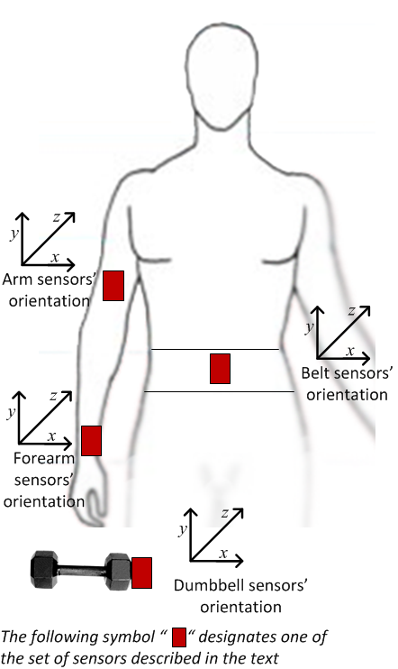
Velloso, E.; Bulling, A.; Gellersen, H.; Ugulino, W.; Fuks, H.
Qualitative Activity Recognition of Weight Lifting Exercises. Proceedings of 4th International Conference in Cooperation with SIGCHI (Augmented Human '13) . Stuttgart, Germany: ACM SIGCHI, 2013.
Source: http://groupware.les.inf.puc-rio.br/har

- First we look at the training data set and we can observe that there is a very long list of predictors, 156 in total with the last variable, “classe”, the outcome we are trying to build a prediction model for.

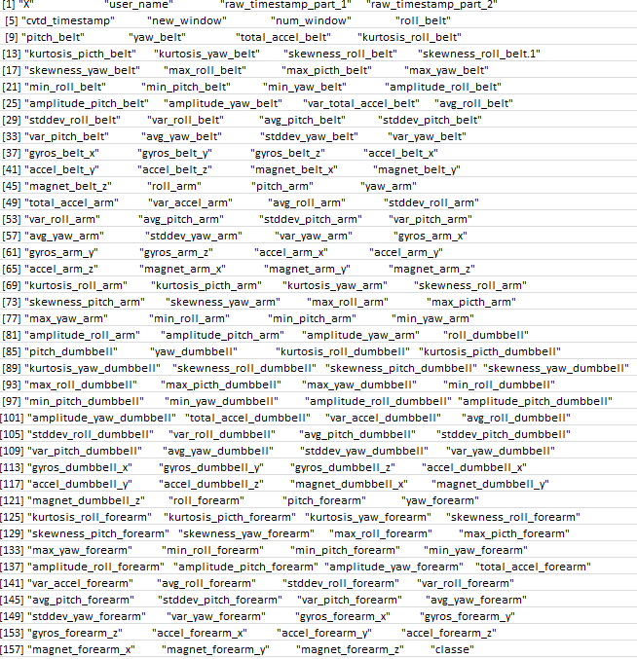

- It makes sense to select only the best predictors in the training and test sets. To do so, we weed out poor predictors which exhibit little or no variance (i.e. close to being constants) using the nearZeroVar function
  - In addition we remove predictors which intuitively do not correlate with the outcome “classe” such as the name of the , time of day, the window data. These should have little bearing on predicting the 5 classes: sitting-down, standing-up, standing, walking, and sitting
  - This leaves us with a streamlined list of better predictors (52 in total) which we focus on to build the best prediction model

"roll_belt" "pitch_belt" "yaw_belt" "total_accel_belt" "gyros_belt_x" "gyros_belt_y" "gyros_belt_z" "accel_belt_x" "accel_belt_y" "accel_belt_z" "magnet_belt_x" "magnet_belt_y" "magnet_belt_z" "roll_arm" "pitch_arm" "yaw_arm" "total_accel_arm" "gyros_arm_x" "gyros_arm_y" "gyros_arm_z" "accel_arm_x""accel_arm_y" "accel_arm_z" "magnet_arm_x" "magnet_arm_y" "magnet_arm_z" "roll_dumbbell" "pitch_dumbbell" yaw_dumbbell" "total_accel_dumbbell" "gyros_dumbbell_x" "gyros_dumbbell_y" gyros_dumbbell_z" accel_dumbbell_x" "accel_dumbbell_y" "accel_dumbbell_z" magnet_dumbbell_x" "magnet_dumbbell_y" "magnet_dumbbell_z" "roll_forearm" "pitch_forearm" "yaw_forearm" "gyros_forearm_x" "gyros_forearm_y" "gyros_forearm_z" "accel_forearm_x" "accel_forearm_y" "accel_forearm_z" "magnet_forearm_x" "magnet_forearm_y" "magnet_forearm_z"

- After sub-setting the training and test sets with this more concise list of predictors, we now try different machine learning prediction algorithms and check for their accuracy.
  - GLM: I could not make the glm training model work (error: Something is wrong; all the Accuracy metric values are missing)
    - No accuracy Results

  - RPART: the Use of the Recursive Partitioning and Regression Trees methodology to predict the class outcome (classe) shows close to a 50% level of accuracy. This is pretty poor
    - Output of the model shows a 49% accuracy:
# Prediction A B C D E
# A 1518 449 460 399 159
# B 29 386 34 184 149
# C 122 304 532 381 297
# D 0 0 0 0 0
# E 5 0 0 0 477
#
# Overall Statistics
#
# Accuracy : 0.495
# 95% CI : (0.4821, 0.5078)

  - RF: the use random forest methodology with out of bag to predict the class outcome (classe) yields close to a 99% level of accuracy. Which is very good even though it is maybe too optimistic
    - Output of the model shows a 99% accuracy:
# Prediction A B C D E
# A 1673 12 0 0 0
# B 0 1124 3 0 0
# C 0 3 1018 10 1
# D 0 0 5 953 5
# E 1 0 0 1 1076
#
# Overall Statistics
#
# Accuracy : 0.993
# 95% CI : (0.9906, 0.995)

- Finally, we use run the highest accuracy model (99%) - the Random Forest model - against the real test data set
  - The model returns the following predictions against the 20 test cases which after submission gave 100% of correct results:
# [1] B A B A A E D B A A B C B A E E A B B B

